A
Report

On

Students’ Seminar
Session- 2017-18

Department of Philosophy
Rabindra Mahavidyalaya,
Champadanga

Theme:
View of Nature According to Spinoza
Venue: Department of Philosophy
R.N. 48
Date: February 23, 2018
Organizer: Department of Philosophy
Paper Presenters: Students of Semester VI (Hons.)
Audience: Students of Semester II, IV and VI (Hons.)

Objectives
- Learn a systematic study of ideas and issues;
- Pursuit of fundamental truths, a quest for a comprehensive understanding of the world, a study of principles of conduct and much more.
• Development of Discussion skills, exhibit independence and flexibility of thought, and time management;
- Stimulate listening skills, argumentative skills and critical thinking;

Proceedings
The seminar, hosted by Prof. SanchitaKheto, began with the introductory speech given by Prof. Hasina Sikdar, Assistant Professor of Department of Philosophy of the institution. All three technical sessions were chaired by the departmental faculties. Prof. Soumitra Das and Prof. Hasina Sikdar acted as judges. Prof. Soumitra Das monitored the whole session. There were three groups of paper presenters, each group containing not less than three students. All sessions were very interactive where pupils have been quite enthusiastic, and all of their questions have been satisfactorily answered. 53 students (Male: 13, Female: 40) participated in the seminar. The seminar ended with vote of thanks by Prof. Hasina Sikdar.
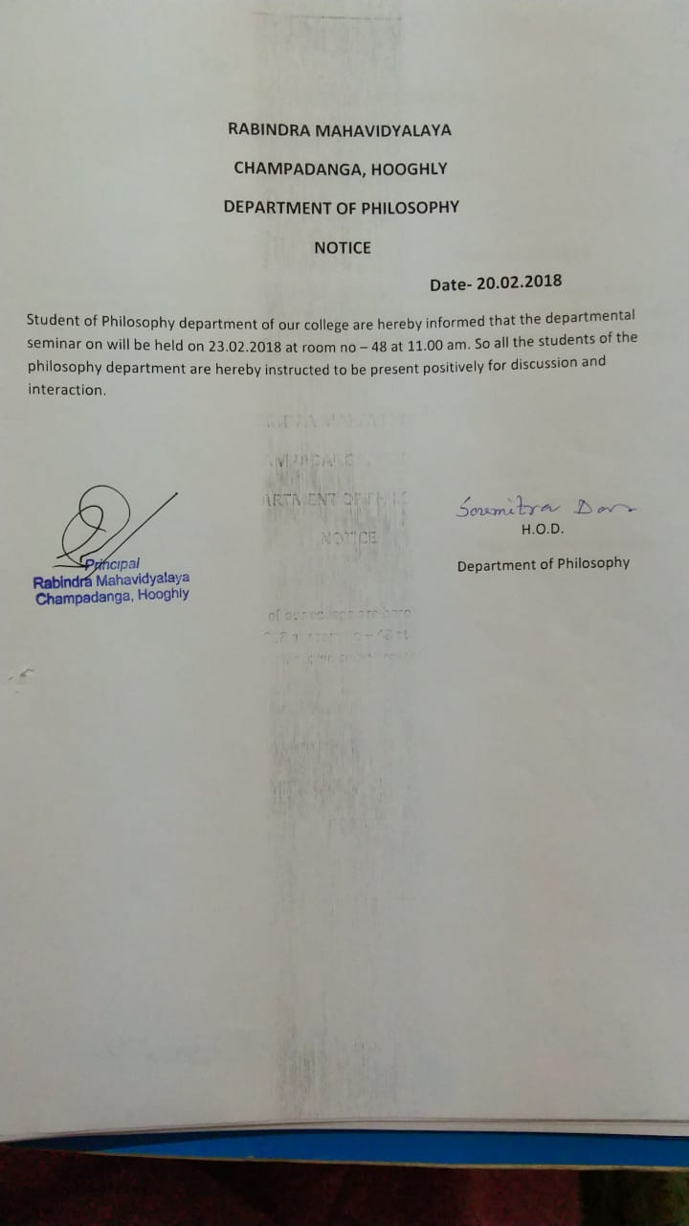

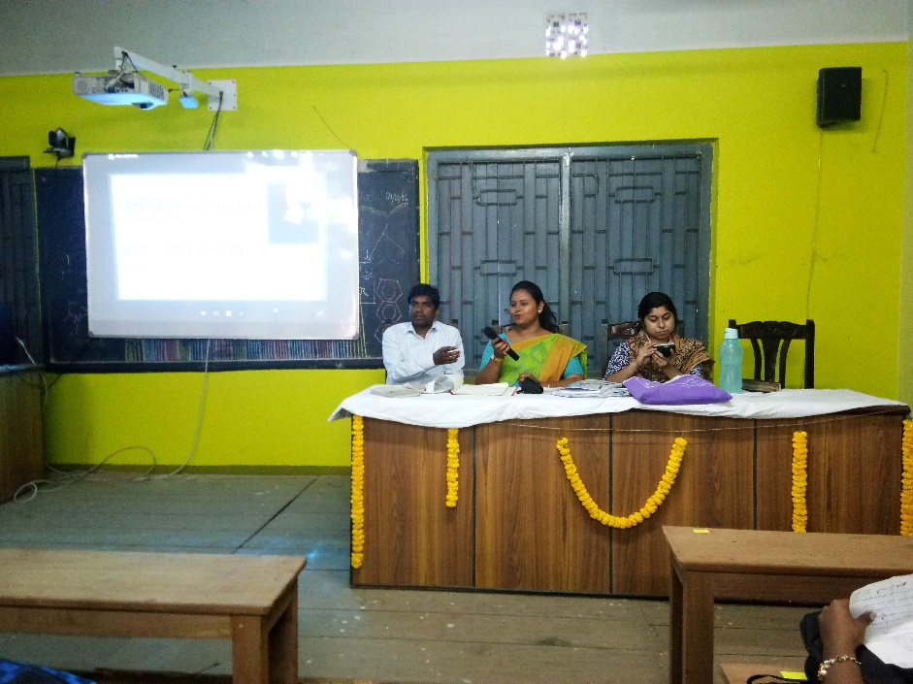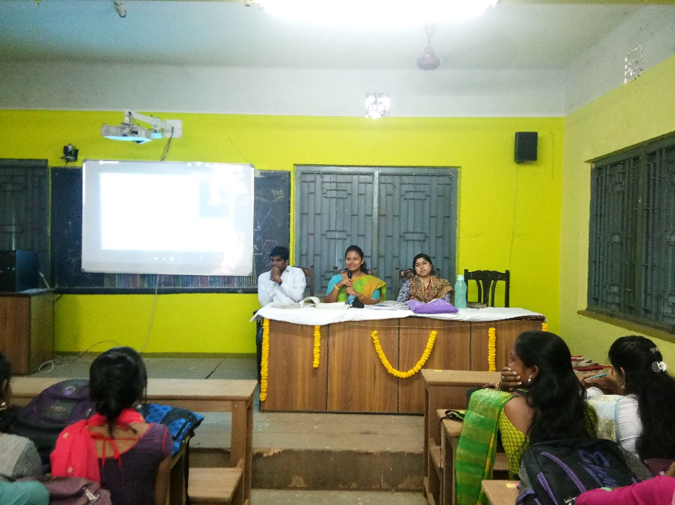
Inaugural speech by prof. sanchita kheto
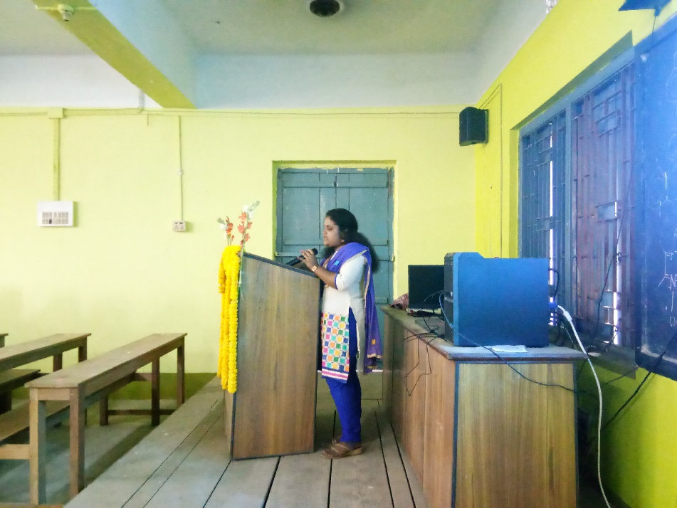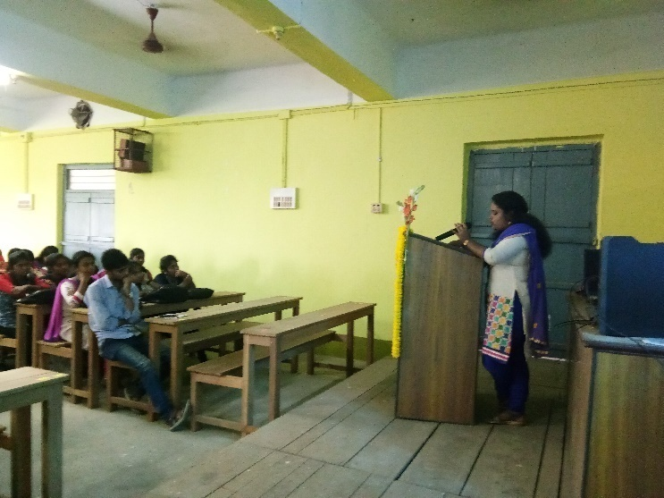
Paper presented by the student
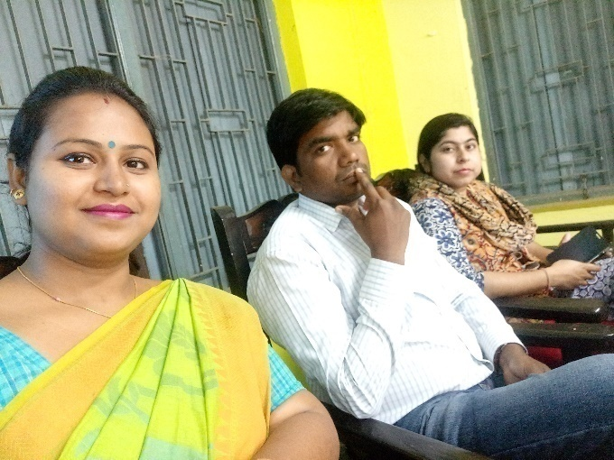

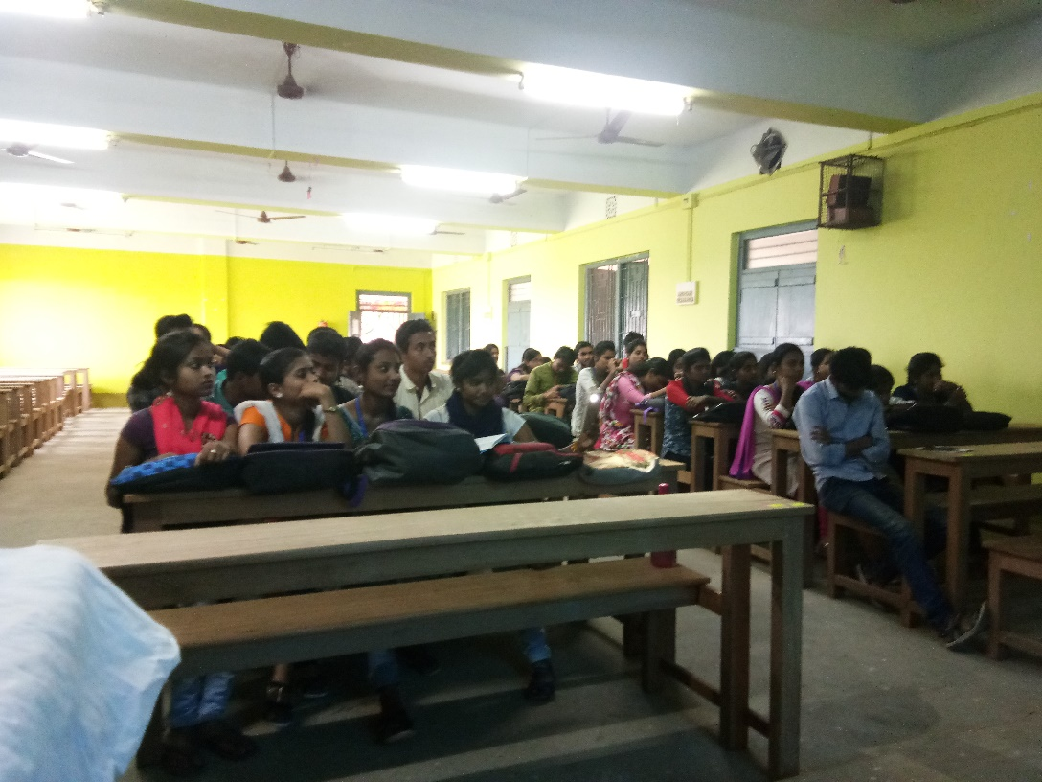
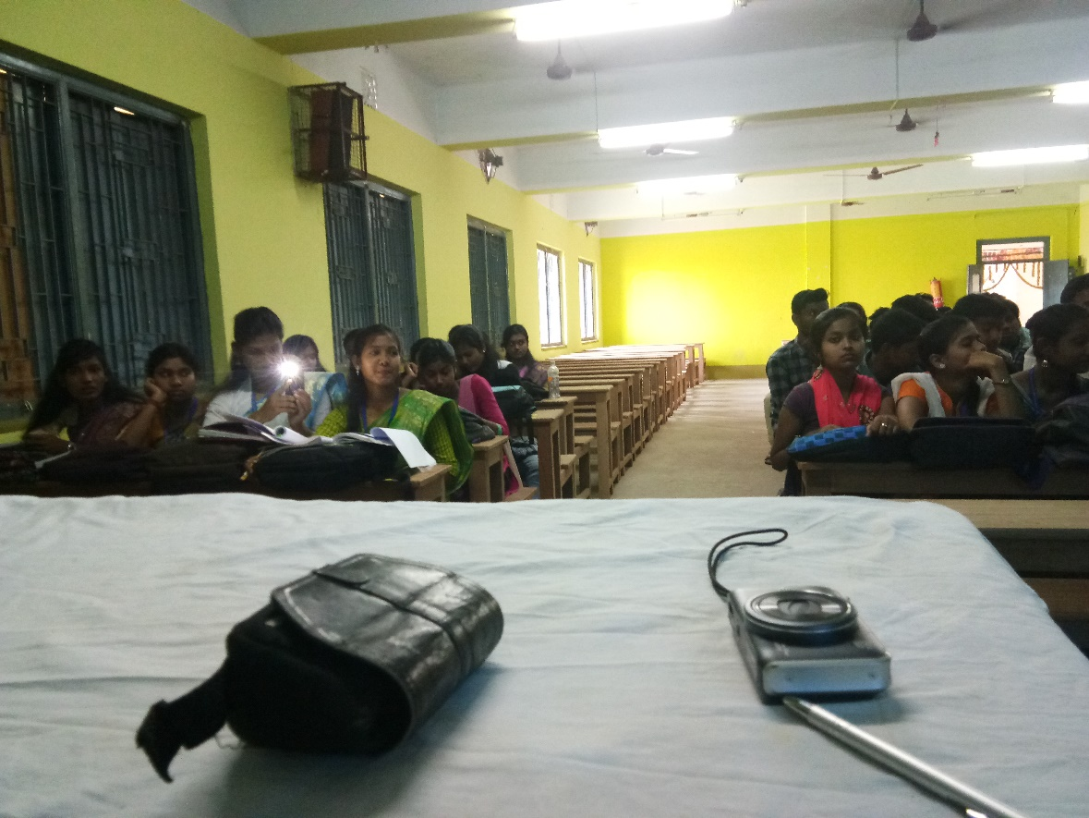
Our students as audience

Attendance:
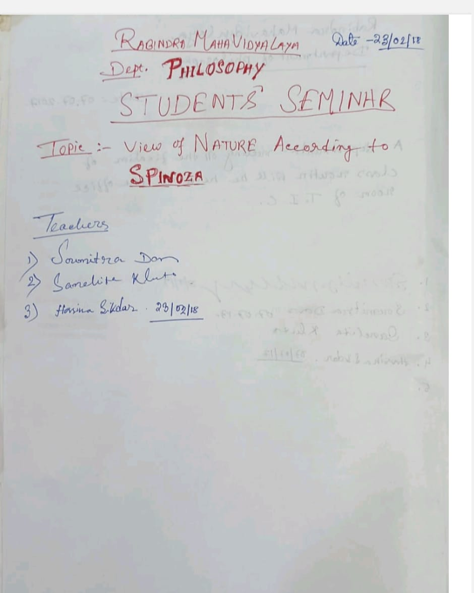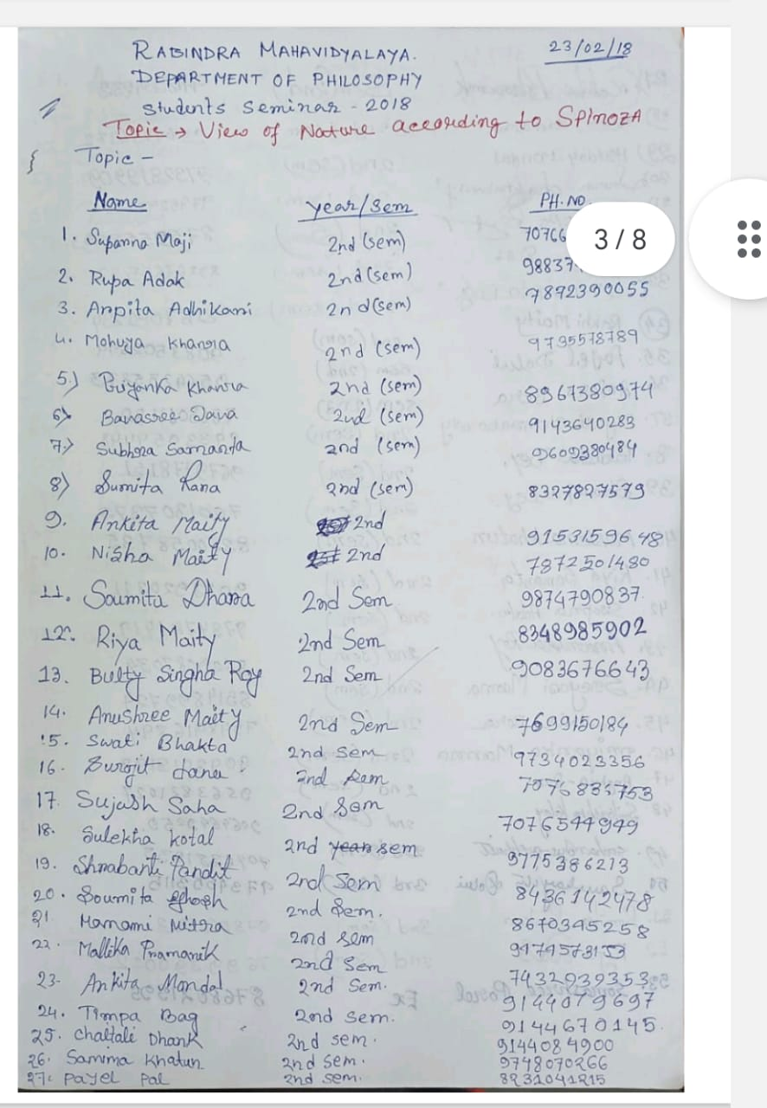

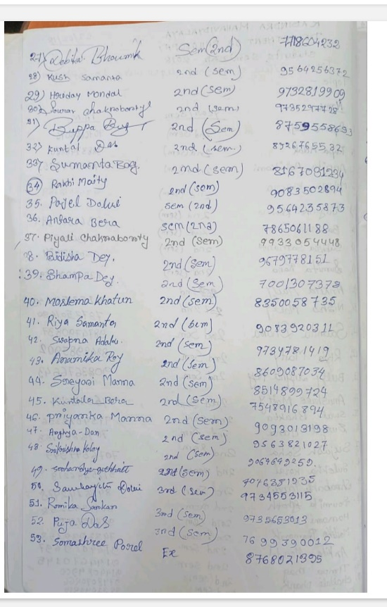

Student’s Seminar
Theme: View of Nature According to Spinoza
Date: 23.02.2018
Venue: Department of Philosophy, Rabindra Mahavidyalaya, Champadanga
Time: 12 noon to 3 p.m.

- Inauguration
- Principal’s Speech
- Technical Session 1: 12.30 p.m. to 1.15 p.m.

- Chairman: Hasina Sikdar
- Rapporteur:Soumitra Das
- Paper: Relation with nature and substance
- Lunch Break

- Technical Session 2: 1.30 p.m. to 2.15 p.m.

- Chairman: Soumitra Das
- Rapporteur: Hasina Sikdar
- Paper: Relation with nature and God
- Technical Session 3: 2.20 p.m. to 3.05 p.m.

- Chairman: Hasina Sikdar
- Rapporteur: Soumitra Das
- Paper: Substance, God and Nature are equal
- Prize Distribution
- Vote of Thanks: Prof. Hasina Sikdar

Student’s Seminar

List of Participants

Theme: View of Nature According to Spinoza
Date: 23.02.2018
Venue: Department of Philosophy, Rabindra Mahavidyalaya, Champadanga
Time: 12 noon to 3 p.m.

- Paper: রবীন্দ্রনাথের দর্শনে মানবতাবাদের ধারণা

- Presenters: SomashreePorel,
Nisha Maity, Sumita Rana & Riya Maity.

- Paper: বিবেকানন্দের চিন্তনে মানবতাবাদ ও তার প্রয়োগ
- Presenters:BadshaMidye,
DebikaBhoumik, Anamika Manna & Krishna Patra.

- Paper: স্বামী বিবেকানন্দের অখণ্ড মানবতাবাদের ধারণা
- Presenters: SanchayitaDolui,
Banasreejana, Shampa Dey & Kajal Psawan.

Feedback Summary
- 48 responses (75%) received.
- 82% felt satisfactory.
- 90% opined the event helped to improve their academic performance.
- 75% wished to occur the events more than once every year.

What have students learnt from the event?
- Presentation skills;
- Self-confidence;
- Critical thinking;

Suggestions
- More extra-curricular activities and healthy competition;
- Special class for grooming;

